Deep Learning Project – Matthew Channell

The use of deep learning and neural networks were used to help select applicants for funding with the beset chance of success, and went through 34,000 organizations.

**Data Cleaning**

The dataset was imported to Pandas, and initially drops unwanted columns “EIN” and “NAME”, while all other columns were kept as features. Both “APPLICATION_TYPE” and “CLASSIFICATION” were binned based off of certain values (see below) to simplify the large number of different groups within each. Then the “IS_SUCCESSFUL” column was used as the y variable and removed from the df, while the rest was used as X in the test_train_split.

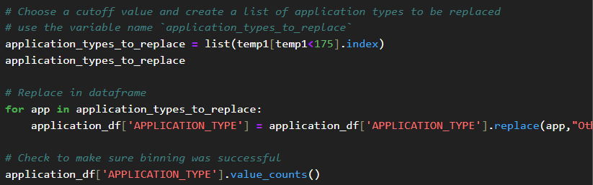

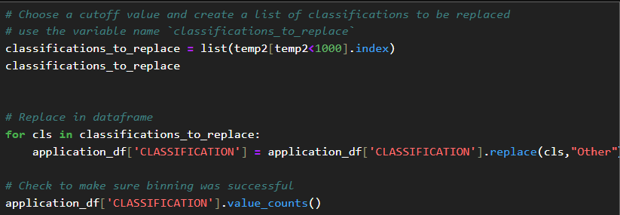

**Defining and Training of the Model**

The NN model was setup in a manner to have 3 layers in total, the with the two hidden layers having input dimensions equal to the number of units.

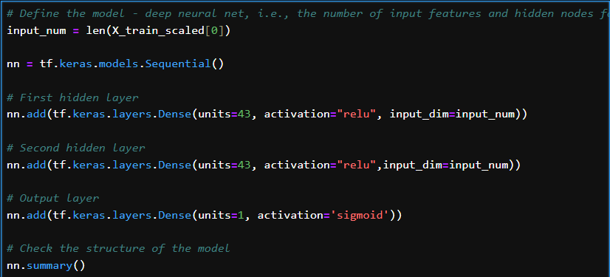

This resulted in a 73% accuracy, as shown below.

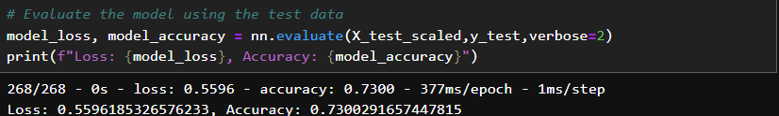

2nd attempt to optimize.

The second attempt to try to increase the accuracy of the model, was lowering the cutoff threshold for the the “APPLICATION_TYPE” and “CLASSIFICATION” binning to much lower numbers, to possibly give the model a bigger array of diversity to learn from. Turns out this lowers the accuracy of the model, as shown below.

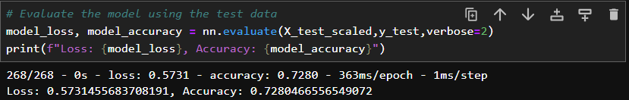

3rd Attempt to optimize.

For the final attempt to bring the accuracy above 75%, initially the Name column was restored to the datset, however the system the model was run on did not have enough memory to run the model training for this big of a dataset. So instead, the “ASK_AMT” column was dropped after going back to where the model was after first attempt, however this also lowered the accuracy of the model.